# Access to Leeds 2022 Study Skills Evaluation

We asked students to self-evaluate their skills before and after they completed the Study Skills element of the Access to Leeds Module.

For this report, we only show the data for the same 90 respondents who completed the survey before and after they completed the module (or pre- and post-module).

## Pre- and post-Module survey result averages for each question

Questions in the survey were grouped into eight different areas relating to study skills questions. Respondents could score from a minimum of 1 point meaning ‘completely disagree’ to a maximum of 7 points ‘completely agree’.

The following graph shows average scores for each question before and after taking the module.

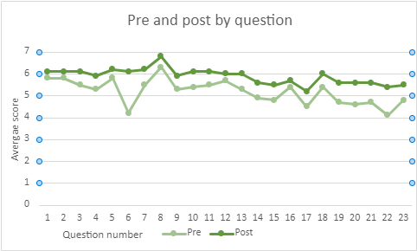

The table on the next page breaks displays the scores for each question:

| **Question** | **Average score before module** | **Average score after module** |
| --- | --- | --- |
| 1. I find it easy to take notes I can refer back to | 5.8 | 6.1 |
| 2. I can think critically about texts I read | 5.8 | 6.1 |
| 3. I feel comfortable keeping track of my reading | 5.5 | 6.1 |
| 4. I know how to write my work in an academic style | 5.3 | 5.9 |
| 5. I can analyse an assignment question to work out what I have to do | 5.8 | 6.2 |
| 6. I understand the skills needed to write a university assignment | 4.2 | 6.1 |
| 7. I understand how to make it clear what sources of information I’ve referred to in my work | 5.5 | 6.2 |
| 8. I know how important it is to give credit when I refer to other peoples’ work in my assignments | 6.3 | 6.8 |
| 9. I feel comfortable with using referencing to show where information in my assignments comes from | 5.3 | 5.9 |
| 10. I can plan my time in exams to make sure I get all the questions finished as I’d like to | 5.5 | 6.1 |
| 11. I know how to break down my work into smaller chunks to help me to make a plan | 5.5 | 6.1 |
| 12. I understand what works best for me when I study, in terms of my working environment and the amount of time I can successfully study for | 5.7 | 6 |
| 13. I feel like I understand what exam revision techniques work best for me | 5.5 | 6 |
| 14. When I’m preparing for or in an exam situation, I know how to manage my stress levels so they don’t affect my performance | 5 | 5.6 |
| 15. I understand techniques I can use to make presentations interesting to listeners | 4.7 | 5.5 |
| 16. I feel like I can plan a presentation to get my point across clearly | 5.3 | 5.7 |
| 17. I know tips on how to manage being nervous whilst giving a presentation | 4.4 | 5.2 |
| 18. I feel I have the level of maths skills I’ll need for the start of my undergraduate course | 4.7 | 6 |
| 19. I understand the type of maths I may be expected to use on my course | 4.2 | 5.6 |
| 20. I understand where I can go to refresh my memory on maths skills if I need to | 4 | 5.6 |
| 21. I feel I can write a scientific assignment well, making sure I use precise language to express the practical aspects of any experiments I am writing about | 4.1 | 5.6 |
| 22. I understand the style I need to write in for a scientific academic assignment | 3.7 | 5.4 |
| 23. I know how to be objective and analytical in scientific assignments, particularly when concluding the significance of my findings | 4.2 | 5.5 |

As you can see from the previous graph and table, every question in the survey reported an overall higher score in the post-A2L Module survey results, indicating that the respondents felt that their skills had improved upon taking part in the A2L Module.

For example, question 6 (‘I understand the skills needed to write a university assignment’) showed a significant change between the pre- and post-A2L Module results, showing that respondents felt more knowledgeable and confident in completing university assignments, which relates directly across all aspects of the A2L Module.

The twenty-three questions in the survey were split into eight sections:

1. Critical reading and note taking
2. Academic writing
3. Referencing and academic integrity
4. Time management
5. Exams and revision
6. Presentation skills
7. Maths
8. Science.

## Pre- and post-Module survey result averages by section

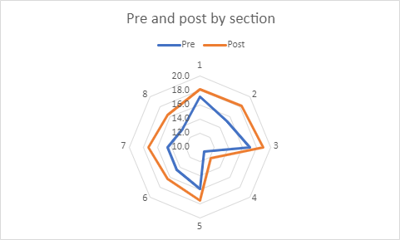The graph and table that follows compare the pre- and post-A2L Module question sections by their total combined average scores.

| **Section** | **Average score before module** | **Average score after module** |
| --- | --- | --- |
| Critical reading and note taking (questions 1-3) | 17.1 | 18.2 |
| Academic writing (questions 4-6) | 15.2 | 18.2 |
| Referencing and academic integrity (questions 7-9) | 17.1 | 18.9 |
| Time management (questions 10-11) | 11 | 12.2 |
| Exams and revision (questions 12- 14) | 16.2 | 17.6 |
| Presentation skills (questions 15-17) | 14.4 | 16.4 |
| Maths (questions 18-20) | 12.9 | 17.3 |
| Science (questions 21-23) | 12.1 | 16.4 |

The previous graph and table show that the Access to Leeds Module has had a largely positive impact on participants’ skills and abilities. For example, section 2 looks at Academic Writing and section 7 looks at Presentation Skills; both of these areas have shown significant improvement in areas across the A2L Module participants’ responses.

## Further opportunities for your development

If you wish to look into further opportunities for personal and academic development outside of the A2L Module, we would recommend you check out the [workshops and resources available through the Skills@Library website](https://library.leeds.ac.uk/info/1400/study_and_research_support).