TIER 4 ENTRY CLEARANCE APPLICATION

PLEASE NOTE: the earliest you can make your application is three months before your course start date. Applications which are submitted more than 3 months before the course start date will be refused and you will have to get a new CAS to apply again.

Make sure you select the correct application form:

Study - PBS Tier 4 Student - Tier 4 (General) Student
Select this option if you will be self or family funded, otherwise privately funded or funded by a student loan, or if you are in receipt of a scholarship from the University of Leeds

Study - PBS Tier 4 Student - Tier 4 (General) (Sponsored) Student
Select this option if you are funded (or partially funded) by an "official financial sponsor", such as the UK government, your home government (though this does not include student loans), the British Council or any international organisation or international company

Study - PBS Tier 4 Student - Tier 4 (Chevening, Marshall and Commonwealth Scholars Only) Student
Select this option if you are the holder of a Chevening Scholarship or Fellowship, a British Marshall Scholarship, a Fulbright Scholarship or a Commonwealth Scholarship and Fellowship Plan

Information for completing the form is detailed below

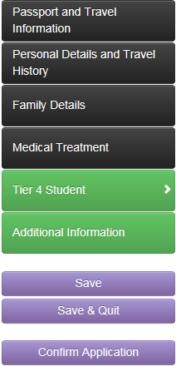

PERSONAL DETAILS AND TRAVEL HISTORY Complete these
FAMILY DETAILS sections and provide
MEDICAL TREATMENT all details requested

PASSPORT AND TRAVEL INFORMATION

Complete this section with the information exactly as it is in your passport.

If you have not yet confirmed/obtained your accommodation in the UK please write the following details:

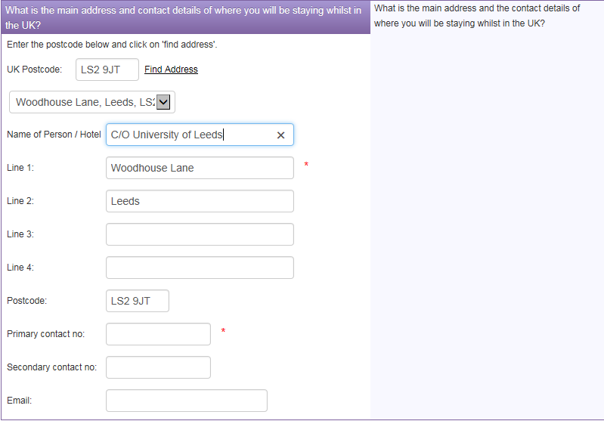

TIER 4 STUDENT

Complete the sponsor details as below

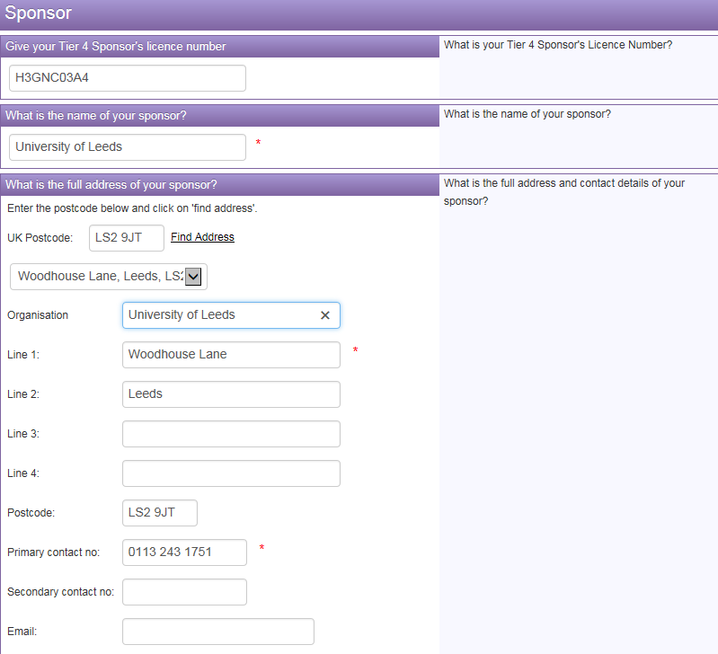

All of the following details will be on your CAS (Confirmation of Acceptance of Studies). Please copy the details exactly from your CAS, for example
The level of course and qualification is:
English Language CEFR B2
Bachelors / Study Abroad NQF6
Masters NQF7
PhD NQF8

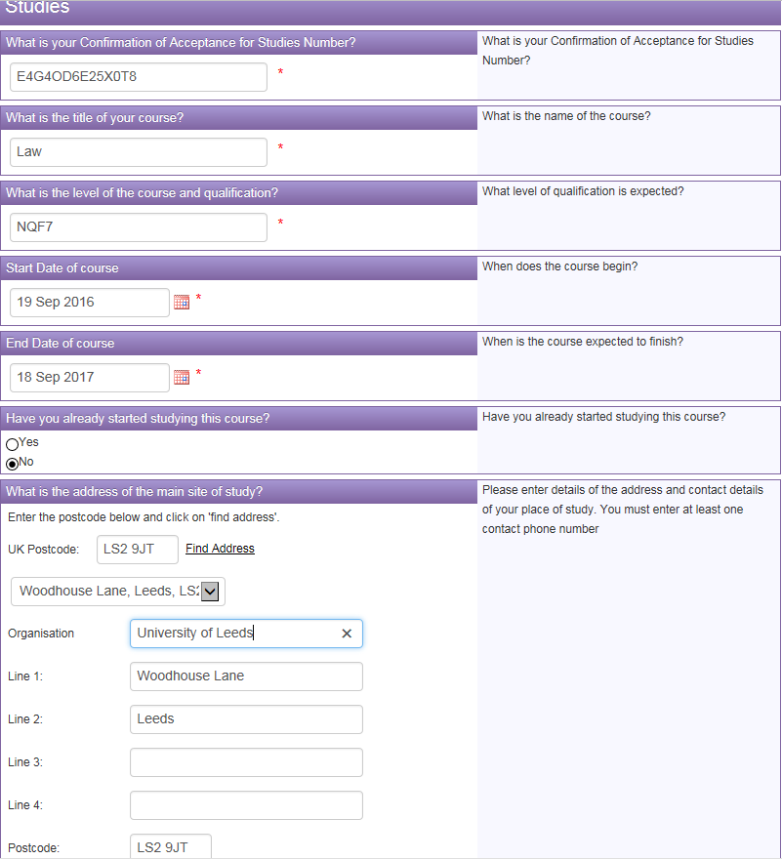
Insert the information as below. The English Language requirement will be confirmed on your CAS under ‘Documents used to obtain the offer’. If it states ‘Higher Education Institution (HEI) sponsor has made assessment’ no English evidence is required and you should select the section as below.
If your CAS states how you meet the English Language requirement i.e. IELTS, select English Language Test and provide details of the certificate.
If you require ATAS, then select Yes and provide details. Your offer letter will tell you if need an ATAS certificate.

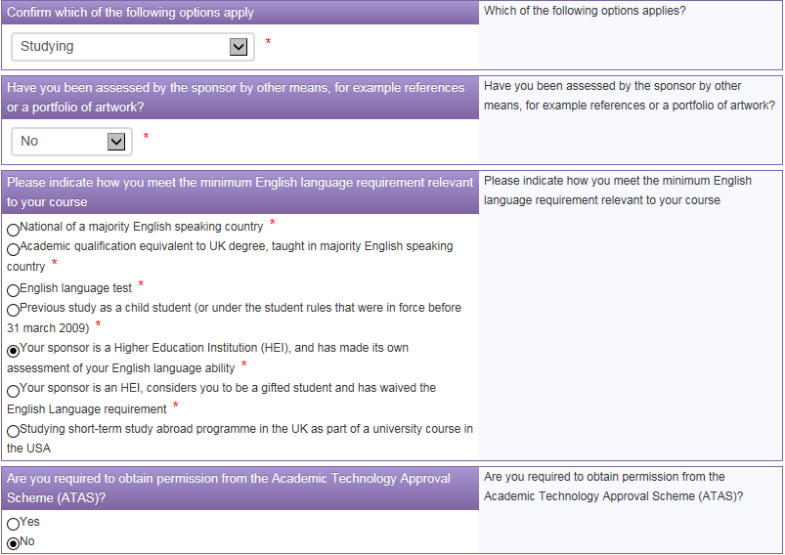

If you are a self-funded student or funded by your parents and have paid a tuition fee deposit or any of your fees, complete the form as below. If you have not paid any tuition fees select No. If the payment is shown on your CAS, select ‘Shown in CAS’. If not, you will need to submit a receipt for the payment and select ‘An official or original receipt’.
If you are a low risk national you do not need to submit any financial evidence, please select ‘Evidence is not required under guidance but held by applicant’
Maintenance fees are your living expenses and include accommodation fees. You will need to show £1,015 per month for 9 months (£9,135) to meet Tier 4 maintenance requirements. If your course duration is less than 9 months, then you need to show £1,015 per month for every month of the course.

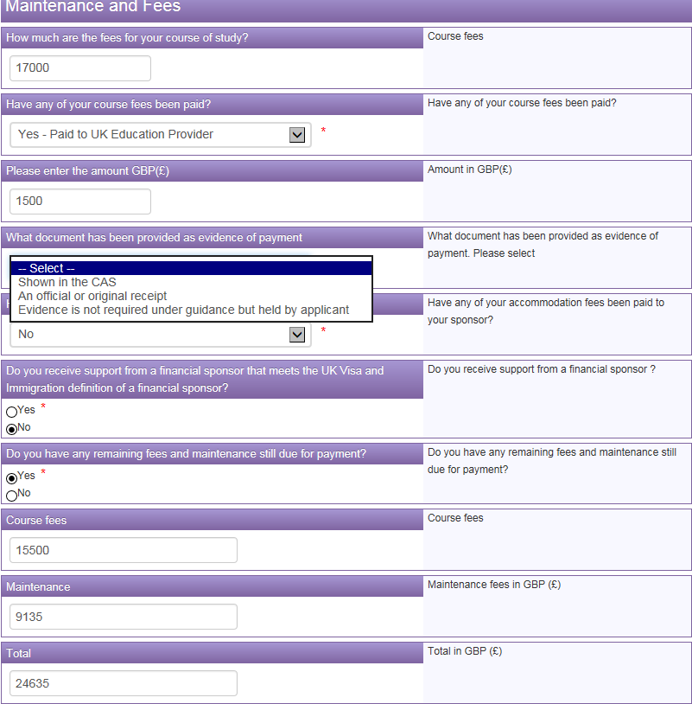
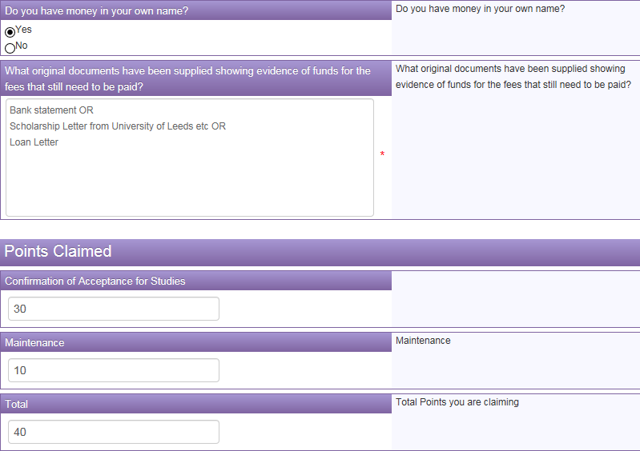

If your parent/s are funding your studies in the UK then complete as follows:

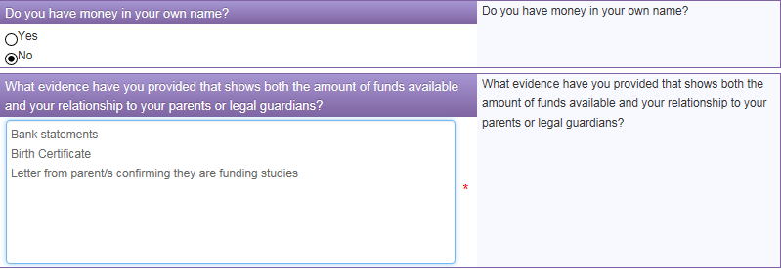

If you are a sponsored student or receiving a scholarship then complete the form as below

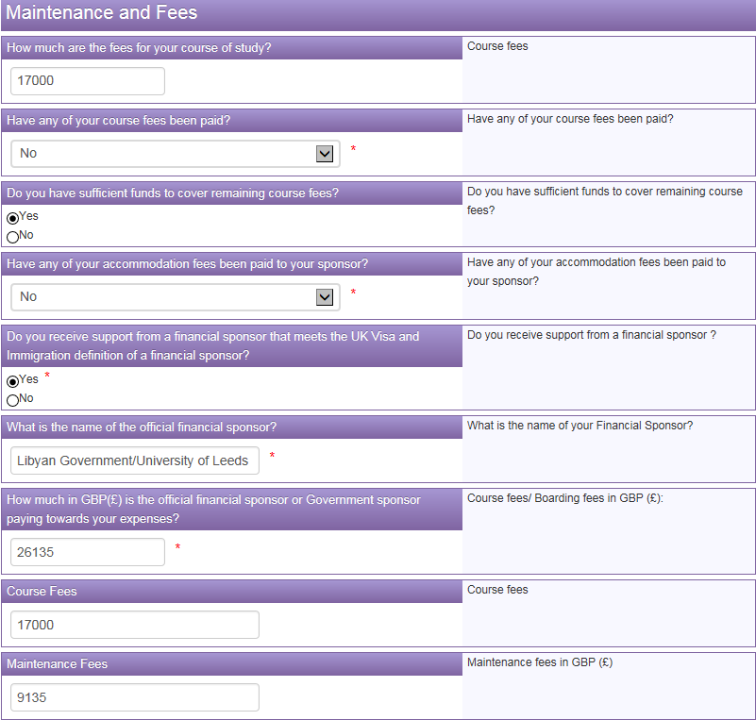
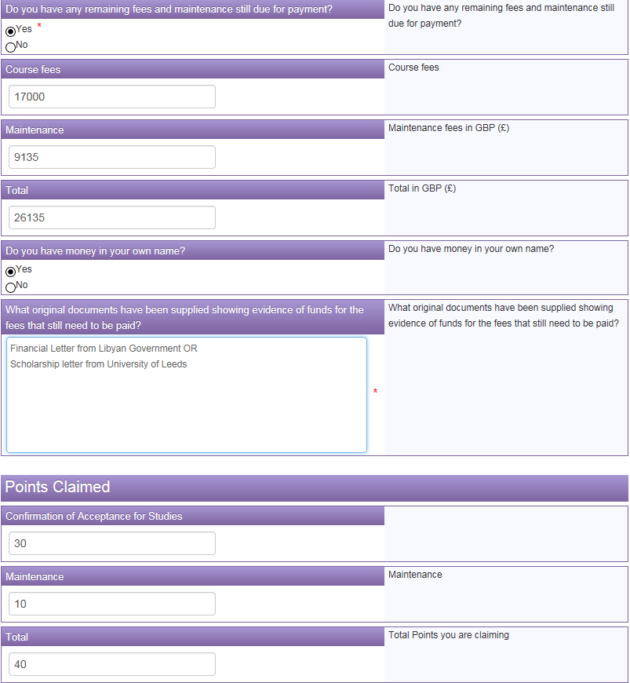

If you are studying for more than 6 months you will be issued a vignette (visa) in your passport which is valid for 30 days. You must then travel within the time limit of that visa and collect your BRP from the University of Leeds.

On the 'Biometric Residence Permit (BRP) Collection' page of the visa application you must insert the University's Alternative Collection Location Code, which is 2HE422. This will make sure that your BRP is sent to the University of Leeds.

If you are studying for less than 6 months your visa will be issued as a vignette (visa) inside your passport for the whole duration of your stay in the UK and you will not need to collect a BRP.

